Three Rivers Section / MBCA

­­

Volume I; Issue I JANUARY 2013

**Three Rivers Road Report**

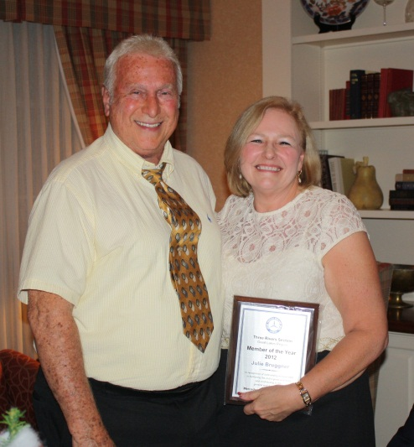Julie Bruggner: Member of the Year

Members of the Three Rivers Section of the Mercedes-Benz Club of America celebrated the holidays Dec. 7 with a dinner at Fort Wayne Country Club. The evening’s highlight was the presentation of the section’s Member of the Year award to Julie Bruggner.

Julie, our membership director, has put in a lot of work to help promote the club and make it fun for members, including a road rally last summer. Cheers to Julie! Above, Julie holds her award next to section president Bob Derek Sr. Below, a group shot.

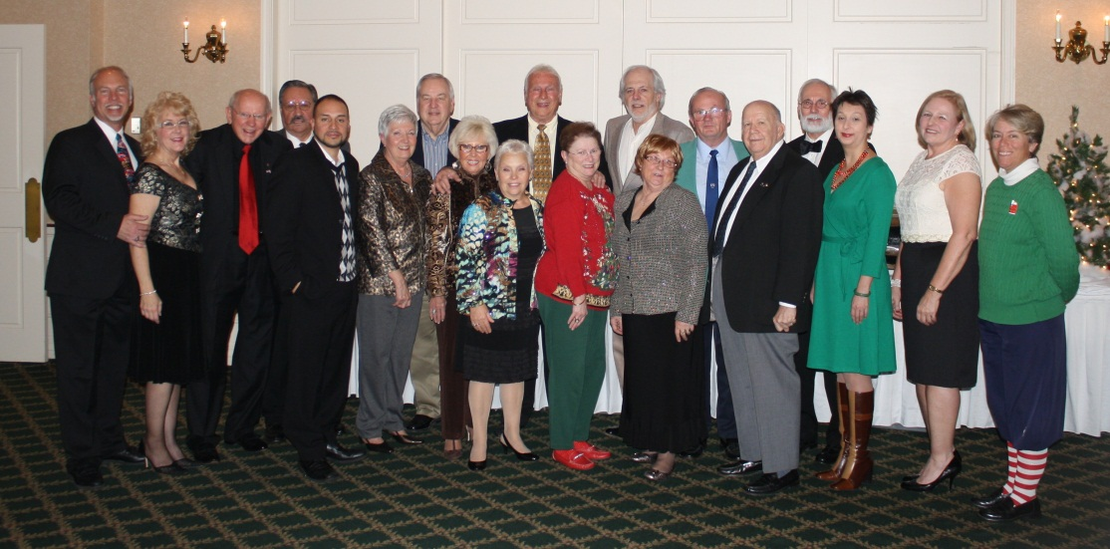

In this issue:

More party photos….4

Officer elections……. 2

Upcoming events ....2

Officer contacts………3

New members……….3

Advertising how-to..4

Officer elections

At its monthly meeting Dec. 15 meeting at Lakeside Café, 1040 N. Coliseum Blvd., the Three Rivers Section voted to keep most of its officers in their same roles and added a new position. Bob Derek Sr. will remain president, Dr. Ralph Merkel vice president, Irma Niederholtmeyer treasurer, and Janice Derek secretary. Lisa Esquivel Long replaces Brian Davies as newsletter editor. Suzanne Noblett was voted to a new position of event coordinator to tie up loose ends and follow through on trips and events.

In a giving mood

Also at its Dec. 15, the group voted on how to divide money collected for donations to local organizations. The group is giving $200 to the Allen County Society for the Prevention of Cruelty to Animals and $400 to Homeless Veterans, both Fort Wayne organizations.

Ron Hite let members know he has an electric wheelchair to donate to someone in need, and members heard that Mustard Seed Furniture Bank needs donations. The group gives free furniture and household items to people coming out of shelters or who are homeless for some other reason, such as fire or disasters.

**Tentative section events for 2013**

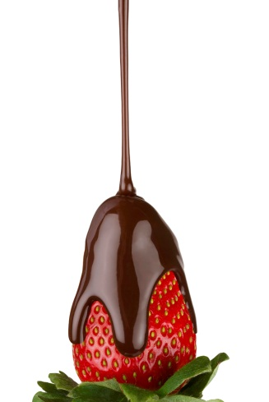Here are some upcoming events members would like to participate in. A complete list of events and prices will be decided at the section’s next meeting: 2 p.m. Feb. 3 (a Sunday) at Country Heritage Winery and Vineyard , 0185 County Road 68, LaOtto (Take Lima Road/Indiana 3 north, turn left onto W County Road 68 S. in about 33 miles.)

* A meeting/pizza party at Lexy's, Leo Crossing (Jan. 13)

 *Tour of the DeBrand Chocolate factory

THREE RIVERS SECTION

PC:\Users\Sentinel5\AppData\Local\Microsoft\Windows\Temporary Internet Files\Content.IE5\0736J39Y\MC900088568[1].wmfresident’s Message

Hello, fellow Benzers, I hope you have enjoyed this mild weather so far. I wanted to put together a wine tasting party this month.

We have a lot of fun events planned for 2013. I hope everyone will join in these club events. Let’s make our club the best one in the Great Lakes Region.

I want to thank everyone for their kind words and thoughts on the passing of my mom. I really appreciate them. Mom almost made it to 104. She had a full life, and can finally rest. She is better off where she is now.  Bob

THREE RIVERS SECTION

Executive Officers & Board of Directors

President: **Bob Derek Sr.** (260) 422-2278 dspksrm@aol.com

Vice President: **Dr. Ralph Merkel** (260) 485-1121 rmerkel2@frontier.com

Treasurer: **Irma Niederholtmeyer** (260) 489-1249 wernerjn@aol.com

Secretary: **Janice Derek** (260) 466-8257 jandbderek@comcast.net

Past President: **Larry Spedden** (260) 432-9577 lspeedo@yahoo.com

Website/Membership: **Julie Bruggner** (260) 348-1369 julesslb@msn.com

Newsletter Editor: **Lisa Esquivel Long** (260) 483-0171 lisalong1@comcast.net

Board At Large: **George Lindsay** (260) 432-5717 gclj@comcast.net

**Welcome, new members**

|  |  |
| --- | --- |
|  | John Friddle and Subhash Reddy, both of Fort Wayne. Three Rivers Section’s total membership is now 62. |

Questions? Call our section leader Bob Derek Sr. at (260) 422-2278 or the National Business Office at 1-800-637-2360 8 a.m.-5 p.m. MT Monday-Friday. Or visit [www.mbca.org](http://www.mbca.org).

Your ad here

Business card ad placement is available at $60/year or $5/month.

1/4 page ads are $120/year or $10/month. 1/2 page $240/year or $20/month.

Full page $480/year or $40/month. Rates for non-MBCA members are double those listed.

Advertisers, send your business card and/or ad plus payment to:

**Irma Niederholtmeyer (Treasurer), 7804 Fritz Rd., Ft Wayne, IN 46818**

More views of the fun at the December holiday party:

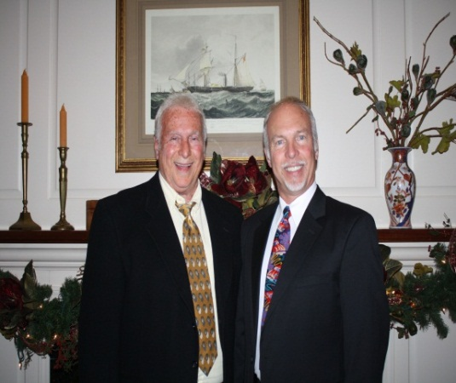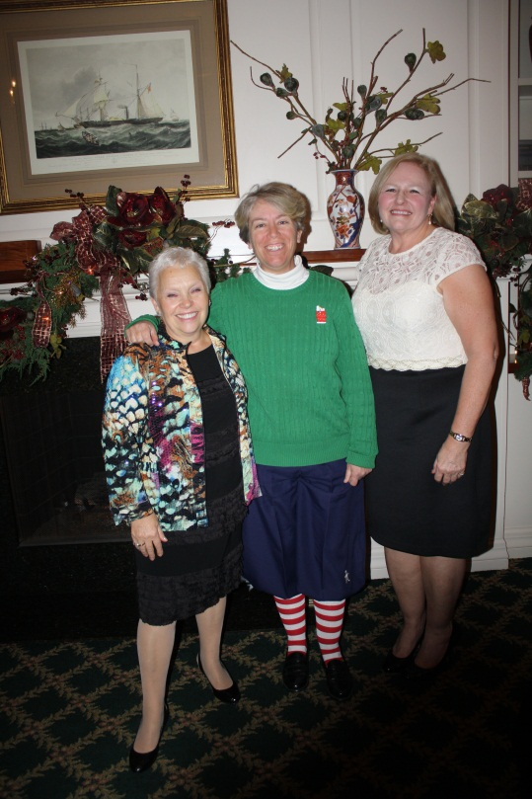

Left: From left, Maxi Merkel, Suzanne Noblett and Julie Bruggner share their holiday cheer.

Below: Father-son members Bob Derek Sr. and Jr.

Party photos courtesy of Janice Derek

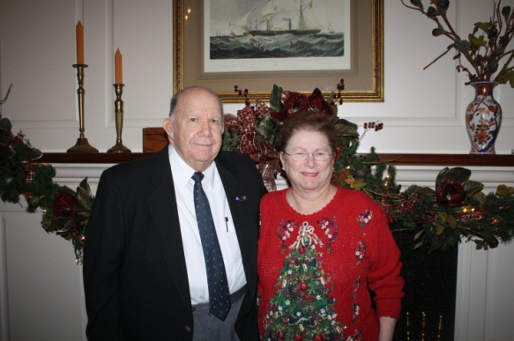

Have club news, event photos or a story about your Mercedes-Benz to share? Contact newsletter editor Lisa Esquivel Long at [lisalong1@comcast.net](mailto:lisalong1@comcast.net). Deadline is the 20th of each month.

Left: Looks like someone is trying for the Best Dressed in Christmas Sweater award. That’s Deardra “D” Lindsay looking festive alongside her husband, George.