­­­­­­­­­Three Rivers Section / MBCA

­­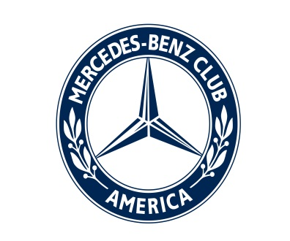

Volume I; Issue 3 MARCH 2013

**Three Rivers Road Report**

A pleasant sundae drive

Here are some sweet reasons to join the Mercedes-Benz Club: dark, white and milk 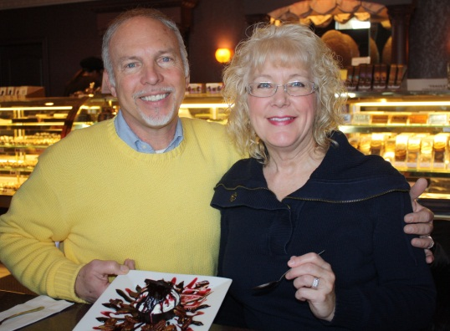CHOCOLATE.

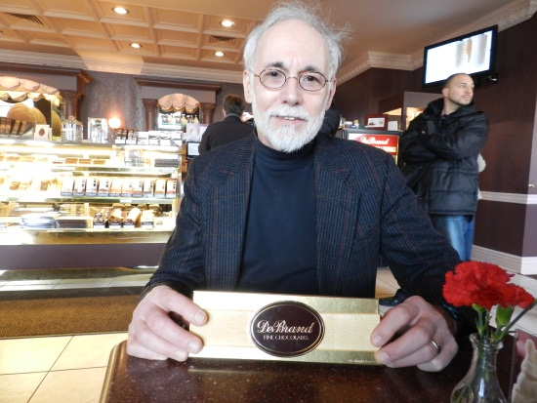Members of the Three Rivers Section toured DeBrand on Feb. 17. It was a delicious time with a chance to see how the confections are made – and sample the sweets made in Fort Wayne and sold around the world – including Kuwait, and maybe*,* Stuttgart? Afterward, members had a chance to socialize over gelato and sundaes.

Bob Jr. and Janice Derek make a sweet couple – our teeth hurt!

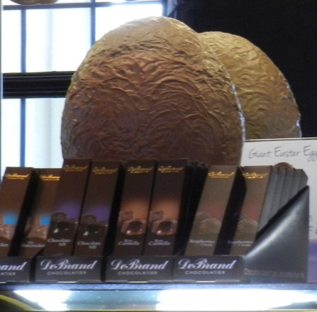

Ken Long, owner of a 1979 450SLC, can’t wait to dive in.

How much for that egg in the window? This giant hollow egg makes a good corporate gift.

## Inside: Car shows, upcoming events and more photos!

## Clockwise from left: Suzanne Noblett cools off with a tall one. Suzanne, and D and George Lindsay, with Jack Dever overlooking them, get cozy. Mike and Stephanie make another sweet couple. Yvonne Hawkins found something sweet…and a sundae to share with him (section president Bob Derek Sr.).

## 

## 

## Everyone say, “CHOCOLATE!”

## Hear those engines wine

## Three Rivers Section members really got into the spirit with a trip Feb. 3 to Country Heritage Winery & Vineyard in LaOtto.

## For free, guests can select five wines to try and are served a small sample of each, along with the wine of the month – February’s was Strawberry. The tastings are free, unless otherwise noted on the wine list. Some of the more expensive wines cost $3 or $5 to sample.

## Members wasted no time in finding a spot at the bar. Afterward, members sat to sample wines they had purchased and had a small meeting to discuss upcoming events. Suzanne Noblett had a tentative calendar of events for the year.

D and George Lindsay are the toast of the town.

Above: A server measures out a sample. Right: D and George Lindsay look like the toast of the town.

## 

## 

## 

## 

Clockwise from top left: Is Mike hiding some bloodshot eyes from Stephanie and Suzanne Noblett?

Section president Bob Derek Sr. finds a drinking friend with Brian Davies. Let’s hope they don’t drink like the one on the wall.

Udo Liell only has eyes for Brenda – but hers are on the camera.

Jackie and Jack Dever say “Cheers.”

Ken and Lisa Long know a good nose.

Photos by Janice Derek

## C:\Users\Sentinel5\AppData\Local\Microsoft\Windows\Temporary Internet Files\Content.IE5\BH2YY3PZ\MC900410407[1].wmfCar shows and upcoming trips the Three Rivers Section discussed participating in:

## *March 24: Automotive Heritage and Elwood Haynes museums in Kokomo. Call Suzanne today to reserve your spot. We’ll be meeting at Don Hall’s Tavern at Coventry, 5745 Coventry Lane, at the opening of Village at Coventry west of the Interstate 69-U.S. 24 intersection at 9 a.m. March 24. ­­­­­We’ll leave Kokomo 4-4:30 p.m.

## *April 21: South Side Soda Shop and Old Bag Factory – Goshen

## *May 18-22: Starfest-Alabama (see separate entry below)

## *June 2: Eurofest car show during Germanfest, 10 a.m.-4 p.m. in Lawton Park. Look on Facebook at Derek Motor Car 2013 Eurofest or call 422-2278.

## *June 16: Father’s Day show Mid-America Windmill Museum – Kendallville

## *July 13: Three Rivers Festival parade

## *July 27: Drive-in movie

## *Aug. 11: Snook’s Car Museum, Bowling Green, Ohio

## *Aug. 31:[Auburn Cord Duesenberg Festival](http://www.acdfestival.org/)

## *Sept. 15: Mystery cruise

## *September: Vin Dever’s Euro Show, Toledo, Ohio; and fall foliage tour of Brown County

## *October: Newport Hill Climb in Newport, Ind., Creepy Car Cruise-In in Auburn; and Halloween costume party.

## *November: Potluck at someone’s house

## *December: Christmas parade in Auburn; Christmas light cruise in Fort Wayne; and a Christmas party.

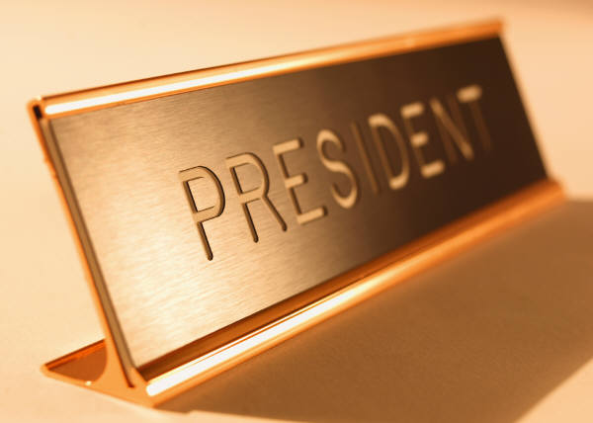**President’s Message:** Happy March, fellow Benzers; Our club has had a fun-filled January and February: pizza party, wine tasting, no-calorie chocolates and great conversations. Special thanks to Susanne for her efforts to put this all together. If you haven’t been to an event this year, get out of your jammies and join us.

We have had good turnouts for these events, but we would like to have more members join us. You may or may not have heard, Julie Brueggner had a shoulder operation, Everything is working fine so far. Happy motoring;  Bob

THREE RIVERS SECTION

Executive Officers & Board of Directors

President: **Bob Derek Sr.** (260) 422-2278 dspksrm@aol.com

Vice President: **Dr. Ralph Merkel** (260) 485-1121 rmerkel2@frontier.com

Treasurer: **Irma Niederholtmeyer** (260) 489-1249 wernerjn@aol.com

Secretary: **Janice Derek** (260) 466-8257 jandbderek@comcast.net

Past President: **Larry Spedden** (260) 432-9577 lspeedo@yahoo.com

Website/Membership: **Julie Bruggner** (260) 348-1369 [julesslb@msn.com](mailto:julesslb@msn.com)

Event Coordinator: **Suzanne Noblett** (260)348-5787 suzanne@noblettgolf.com

Newsletter Editor: **Lisa Esquivel Long** (260) 483-0171 lisalong1@comcast.net

Board At Large: **George Lindsay** (260) 432-5717 gclj@comcast.net

**Thanks for your membership**

|  |  |
| --- | --- |
|  | Vincent and Kathleen Alt of Fort Wayne and Rondald Davidhizer of Goshen renwed their memberships. Dyan Harrington of South Bend joined in February. Three Rivers Section’s total membership is 62. A member’s membership has expired but I’m sure it’s in the process of being renewed! |

Business card ad placement is available at $60/year or $5/month.

1/4 page ads are $120/year or $10/month. 1/2 page $240/year or $20/month.

Full page $480/year or $40/month. Rates for non-MBCA members are double those listed.

Advertisers, send your business card and/or ad plus payment to:

**Irma Niederholtmeyer (Treasurer), 7804 Fritz Rd., Ft Wayne, IN 46818.**

**StarTech 2013 Coming to Birmingham, Ala.**

StarTech® 2013 is coming May 18-21 to Birmingham, Ala. StarTech plans and preparations are in full swing, thanks to a team of MBCA members from across the country who are actively supporting the Event Committee. Host hotel is the Hilton Birmingham Perimeter Park, 1-205-967-2700. Ask for the MBCA block rate of $111 nightly. Dozens of activities and once-in-a-lifetime events are already locked in. **Be sure to save the dates!**

**Sat. May 18:** U.S. Space & Rocket Center in Huntsville, Ala.

**Sun. May 19:** Mercedes-Benz plant tour; drive laps at Barber Motorsports Park; welcome reception at Barber Vintage Motorsports Museum.

**Mon.-Tue. May 20-21:** Technical events at MBUSI facility.

A Web of knowledge

Keep up with the latest trip plans and other information at <http://www.threerivers.mbca.org> and the latest news from sections at [www.mbca.org](http://www.mbca.org), such as “Get to Know Women on Wheels (WOW). Talk to Other Women Owners and Become Your Own Car Care Expert,” a special Viking River Cruises for members from Basel, Switzerland to Amsterdam, Holland Sept. 29-Oct. 6, and the July auction of the “1954 2½-litre straight-8 Mercedes-Benz W196 einsitzer– chassis number ‘00006/54’ – in which five-times World Champion Driver Juan Manuel Fangio won both the 1954 German and Swiss Grand Prix races.”



