Three Rivers Section/MBCA

­­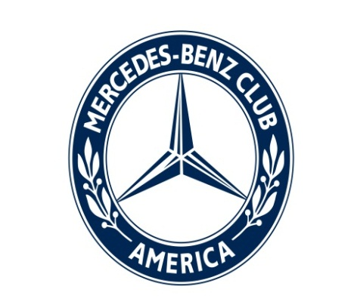

Volume I; Issue 2 FEBRUARY 2013

**Three Rivers Road Report**

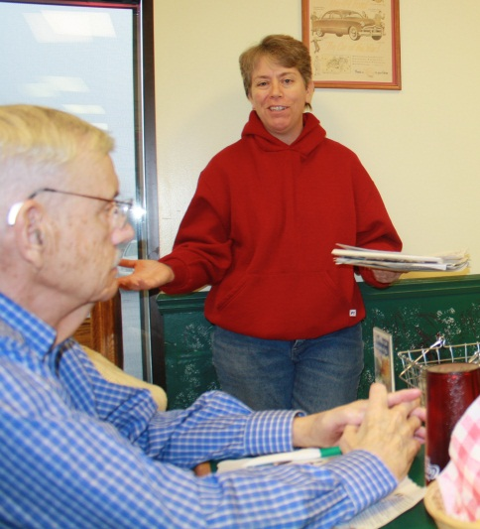Setting the agenda for 2013

Members of the Three Rivers Section of the Mercedes-Benz Club of America will be hitting the road for wine tastings, museums and more this year, thanks to plans presented by recently appointed event coordinator Suzanne Noblett and membership coordinator Julie Bruggner.

Suzanne Noblett offers ideas for club trips while Lawrence McClure and others listen.   
 Photo by Janice Derek

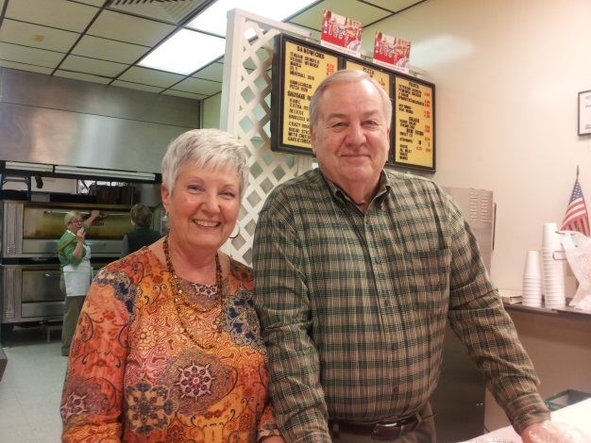Members met Jan. 13 for a meeting with a buffet lunch at Lexy’s Pizza, 10356 Leo Road, owned by section members Ron and Mary Jane Hite. President Bob Derek Sr. was in Houston after the death of his 103-year-old mother, so Vice President Dr. Ralph Merkel officiated.

## The meeting saw several new faces, including Jason Bogart of North Webster and Lawrence McClure of St. Henry, Ohio.

## Inside: Car shows, Page 2; Upcoming events and officer contacts, 3; Photos, 4; StarTech, 5

Mary Jane and Ron Hite hosted the event.   
 Photo by Maxi Merkel

## Suzanne and Julie have several ideas for day trips that the section members could take this year. Among the C:\Users\Sentinel5\AppData\Local\Microsoft\Windows\Temporary Internet Files\Content.IE5\BH2YY3PZ\MC900436964[1].wmfdestinations mentioned were Satek Winery in Fremont, a pre-St. Patrick's Day event at Flannigan’s in Fort Wayne, a wine tasting with a tour of DeBrand Fine Chocolates in Fort Wayne, the Elwood Haynes Museum, in the Kokomo home of the man who designed one of the earliest automobiles made in the United States and invented stainless steel, Red Crown Mini-Museum in a Lafayette Standard Oil Co. gas station built in 1927, and some drive-in restaurants including Snook’s Dream Cars in Bowling Green, Ohio; South Side Soda Shop & Diner in Goshen; and Nick's Kitchen in Huntington.

Member George Lindsay, left, talks with Frank Cozza, Great Lakes Region director, at last year’s show during Germanfest.

Photo by Lisa Esquivel Long

## Vroom…car show news

## Car shows the Three Rivers Section discussed participating in:

## *June 2: European car show during Germanfest

*Toledo Euro Car show. Member and Toledo native Larry Cline can offer some dining options, such as Tony Paco's.

*October-November: Auburn Events that we might take part in: Creepy Car Cruise, Cruise in Halloween, Christmas Parade

## The votes are in

The group voted to change our car show from just German vehicles to all European styles. The hope is that it will draw a wider audience.

Suzanne will get our group into the Kroozin' Calendar, and get several for club members to buy.

C:\Users\Sentinel5\AppData\Local\Microsoft\Windows\Temporary Internet Files\Content.IE5\BH2YY3PZ\MC900410407[1].wmf **Upcoming events**

*Next meeting: **2 p.m. Feb. 3 (Super Bowl Sunday)** at Country Heritage Winery and Vineyard, 0185 County Road 68, LaOtto (Take Lima Road/Indiana 3 north, turn left onto W County Road 68 S. in about 33 miles.) Meet by 1:15 p.m. at the parking lot of Union Chapel Church, 12628 Coldwater Road. It’s across from a Sunoco. Tour is free.

*Tour of DeBrand Fine Chocolates**, 10105 Auburn Park Drive,** at 2 p.m. Feb. 17.  It requires a minimum of 12 people for a private tour, so **let Suzanne know if you can make it**.  Call her at 260-348-5787 ASAP. Cost is $5. You’ll get a coupon for $5 off a $10 purchase. Meet at DeBrand.

*Pre-St. Patrick's Day dinner at Flannigan's at 7 p.m. March 9.  Call Suzanne to reserve your spot. Cost is what you order. Meet there.

**President’s Message:** President Bob Derek Sr. has been dealing with issues related to the recent death of his mother. Check next month’s issue for his message.

THREE RIVERS SECTION

Executive Officers & Board of Directors

President: **Bob Derek Sr.** (260) 422-2278 dspksrm@aol.com

Vice President: **Dr. Ralph Merkel** (260) 485-1121 rmerkel2@frontier.com

Treasurer: **Irma Niederholtmeyer** (260) 489-1249 wernerjn@aol.com

Secretary: **Janice Derek** (260) 466-8257 jandbderek@comcast.net

Past President: **Larry Spedden** (260) 432-9577 lspeedo@yahoo.com

Website/Membership: **Julie Bruggner** (260) 348-1369 [julesslb@msn.com](mailto:julesslb@msn.com)

Event Coordinator: **Suzanne Noblett** (260)348-5787 suzanne@noblettgolf.com

Newsletter Editor: **Lisa Esquivel Long** (260) 483-0171 lisalong1@comcast.net

Board At Large: **George Lindsay** (260) 432-5717 gclj@comcast.net

**Thanks for renewing your membership**

|  |  |
| --- | --- |
|  | Jan Appenzeller of Syracuse, Tom & Nancy Curtis of Elkhart, and Bob & Janice Derek and Jon & Gwen Edmondson, both of Fort Wayne. Three Rivers Section’s total membership is now 63. |

More views of the January meeting at Lexy’s Pizza:

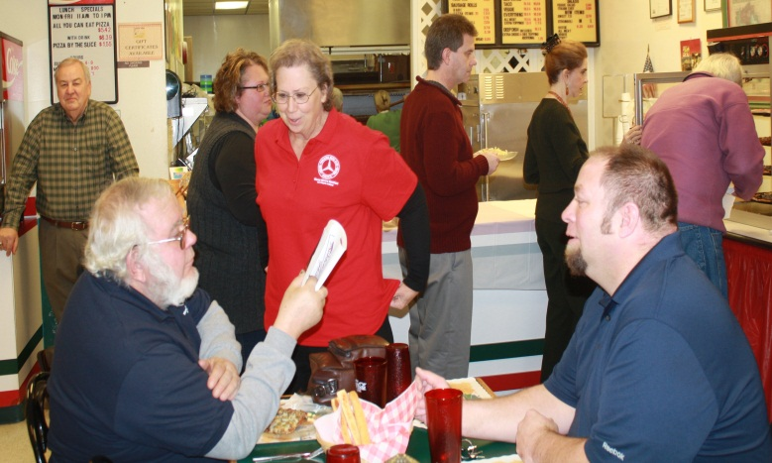

LEFT: Is Udo Liell, left, making a point or just protecting his pizza from Jason Bogart? BELOW FROM LEFT: Janice and Bob Derek Jr. are warm and fuzzy. Ken Long makes a pizza pause. Mike and his girlfriend, Stephanie, are both looking lovely.

Photos by Lisa Esquivel Long and Janice Derek

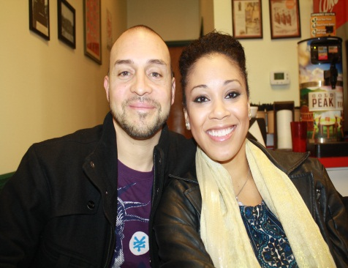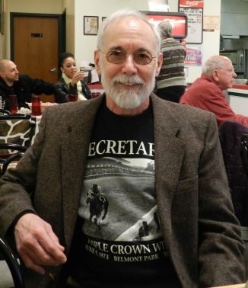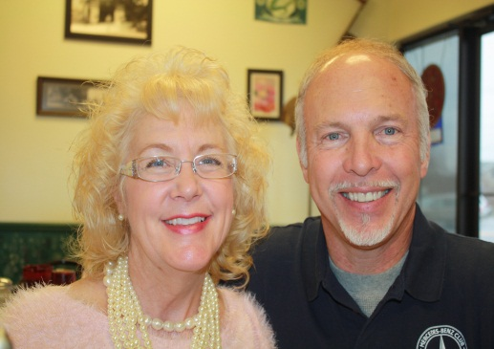

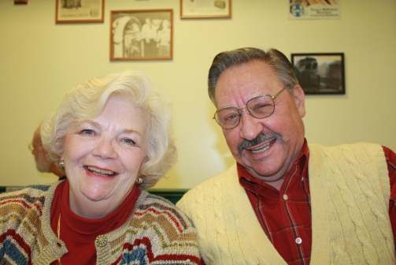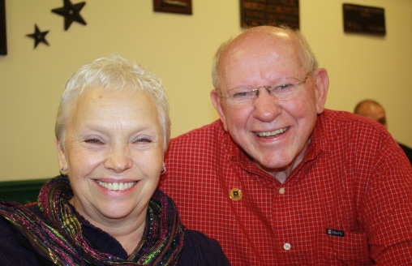  
Above: Jackie and Jack Dever, left, and Maxi and Ralph Merkel, right, say, “Cheese” and pepperoni and sausage…

Questions? Call our section leader Bob Derek Sr. at (260) 422-2278 or the National Business Office at 1-800-637-2360 8 a.m.-5 p.m.

ABOVE: Jackie and Jack Dever, left, and Maxi and Dr. Ralph Merkel say, “cheese,” and pepperoni, and sausage, and …

Questions? Call our section leader Bob Derek Sr. at (260) 422-2278 or the National Business Office at 1-800-637-2360 8 a.m.-5 p.m. MT Monday-Friday. Or visit [www.mbca.org](http://www.mbca.org).

**Your ad here**

Business card ad placement is available at $60/year or $5/month.

1/4 page ads are $120/year or $10/month. 1/2 page $240/year or $20/month.

Full page $480/year or $40/month. Rates for non-MBCA members are double those listed.

Advertisers, send your business card and/or ad plus payment to:

**Irma Niederholtmeyer (Treasurer), 7804 Fritz Rd., Ft Wayne, IN 46818.**

**StarTech 2013 Coming to Birmingham, Ala.**

StarTech® 2013 is coming May 18-21 to Birmingham, Ala. StarTech plans and preparations are in full swing, thanks to a team of MBCA members from across the country who are actively supporting the Event Committee. Host hotel is the Hilton Birmingham Perimeter Park, 1-205-967-2700. Ask for the MBCA block rate of $111 nightly. Dozens of activities and once-in-a-lifetime events are already locked in. **Be sure to save the dates!**

**Sat. May 18:** U.S. Space & Rocket Center in Huntsville, Ala.

**Sun. May 19:** Mercedes-Benz plant tour; drive laps at Barber Motorsports Park; welcome reception at Barber Vintage Motorsports Museum.

**Mon.-Tue. May 20-21:** Technical events at MBUSI facility.

A Web of knowledge

Catch up on national Mercedes-Benz news at [www.mbca.org](http://www.mbca.org), such as an interview with Ola Källenius, the new CEO of Mercedes-AMG GmbH. Also, see the Three Rivers Section’s website at [threerivers.mbca.org](http://www.threerivers.mbca.org/).

